SELECT *

FROM crime_scene_report where type='murder' and city='SQL City' and date=20180115

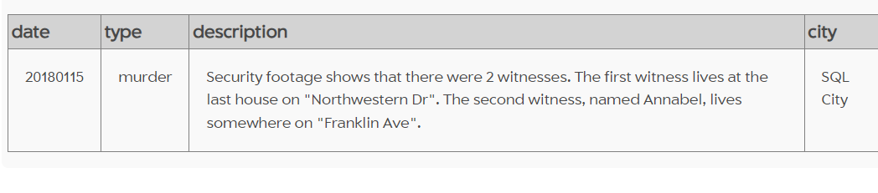

SELECT *

FROM person where address_street_name='Northwestern Dr' or 'Franklin Ave'

SELECT *

FROM person where address_street_name='Northwestern Dr'ORDER BY address_number DESC

limit 1

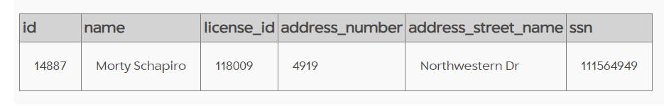

SELECT *

FROM person where name like '%Annabel%' and address_street_name='Franklin Ave'

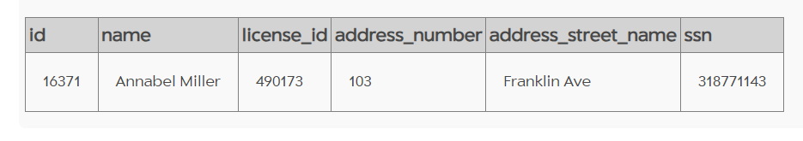

SELECT *

FROM interview where person_id=14887

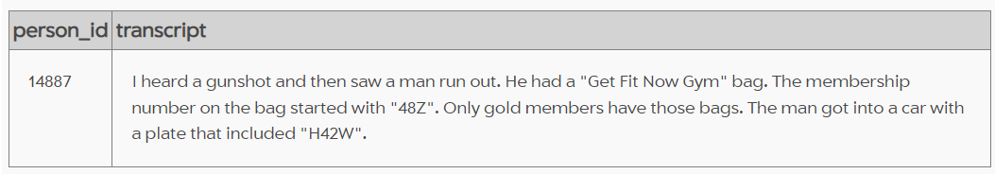

SELECT *

FROM interview where person_id=16371

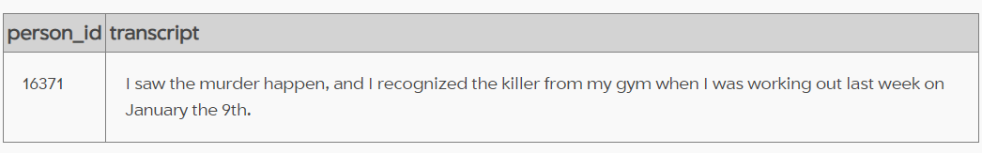

SELECT *

FROM get_fit_now_member

where person_id=16371

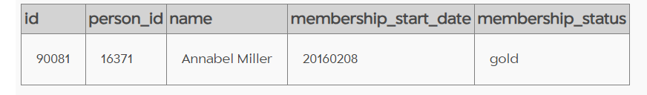

SELECT *

FROM get_fit_now_check_in

where check_in_date=20180109 and membership_id like'%48Z%'

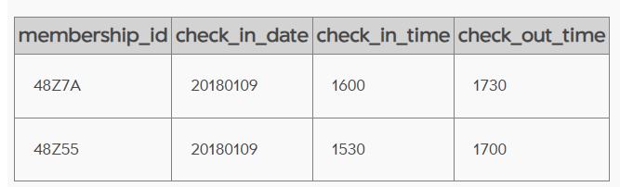

SELECT *

FROM get_fit_now_member

WHERE id = '48Z7A' OR id = '48Z55'

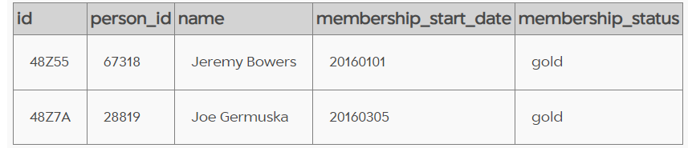

SELECT *

FROM drivers_license

where plate_number like '%H42W%'

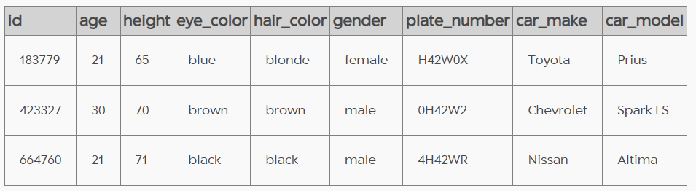

SELECT *

FROM person

where license_id=423327 or license_id=664760

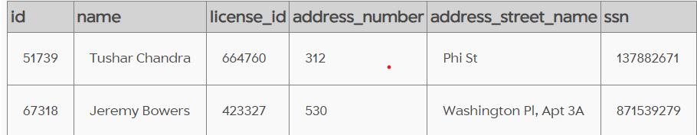

SELECT *

FROM person

WHERE (license_id=423327 OR license_id=664760) AND (id=67318 OR id=28819);

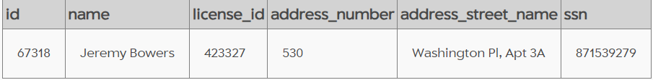

INSERT INTO solution VALUES (1, 'Jeremy Bowers');

SELECT value FROM solution;

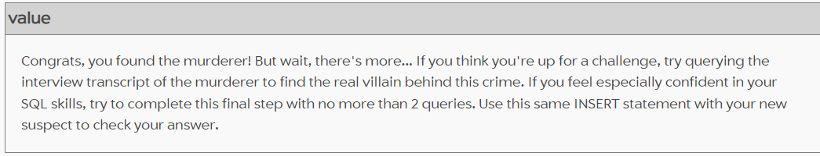

SELECT * FROM interview WHERE person_id = "67318";  
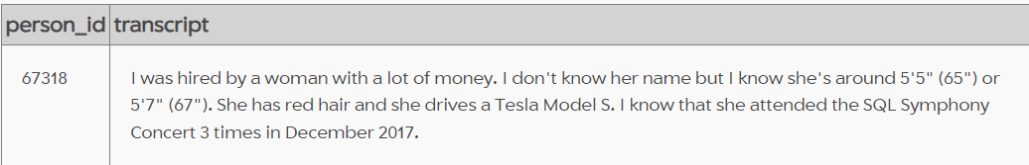

SELECT * FROM drivers_license WHERE gender = "female" AND hair_color = "red" AND height BETWEEN 65 AND 67 AND car_make = "Tesla" AND car_model = "Model S";  
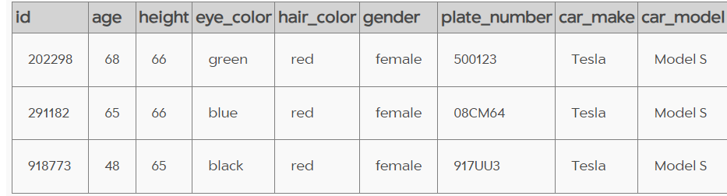

SELECT * FROM person WHERE license_id IN ("202298", "291182", "918773");  
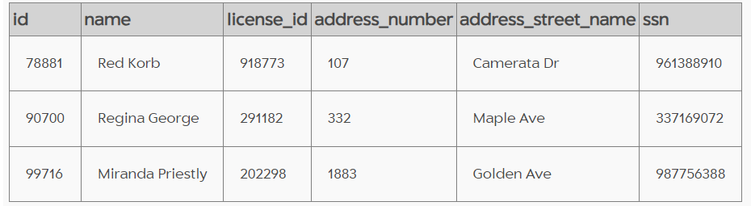

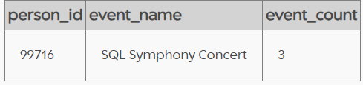SELECT person_id, event_name, COUNT(*) AS event_count FROM facebook_event_checkin WHERE person_id IN ("78881", "90700", "99716") GROUP BY person_id, event_name;

SELECT *

FROM person

WHERE id = 99716;

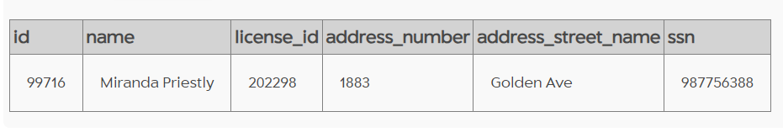

INSERT INTO solution VALUES (1, 'Miranda Priestly');

SELECT value FROM solution;

